**American International University-Bangladesh**

Faculty of Science & Technology (CSE)

**Introduction to Database**

Summer 2022-23

**Section: J, Group: 04**

**Bangladesh Railway e-ticket System**

**Supervised by**

**Kawser Irom Rushee**

|  |  |
| --- | --- |
| **Group Members** | **ID** |
| **MD. IBTIHAZZAMAN** | **22-49153-3** |
| **MD. SAZZAD KHAN** | **22-49172-3** |
| **SAIFUL ISLAM ONI** | **22-49196-3** |

**ER Diagram Scenario**

In Bangladesh Railway e-ticketing system, a passenger may Purchase many tickets. One ticket must be Purchased by exactly one passenger. A passenger is identified by ab email & password. The system also stores passenger’s name, NID, phone number, balance, and security question for security purpose . A ticket is identified by route number & price. While purchasing a ticket, the date of issuing ticket and ticket ID is also stored. A passenger may have ticket history. Ticket history contains ticket ID, train name, departure station, arrival station, issue time & price. Admin manages tickets. Admin has an email address & a password. Admin also operates many trains. A train is identified by train ID & train name. A train has many routes, and a route has also many trains. A route is identified by route ID & route information.

**ER Diagram Making**

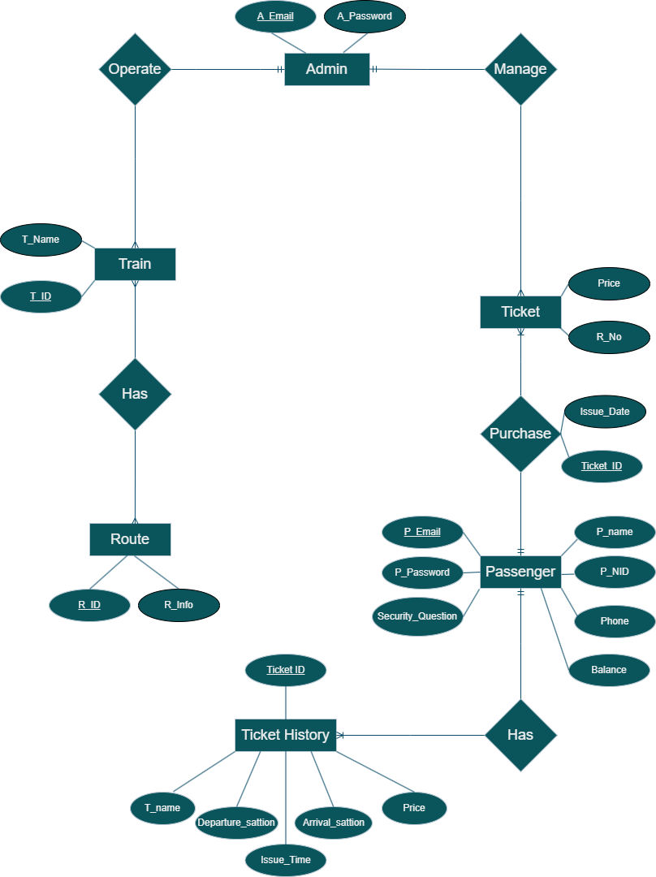**Final ER Diagram**

**Normalization**

1. 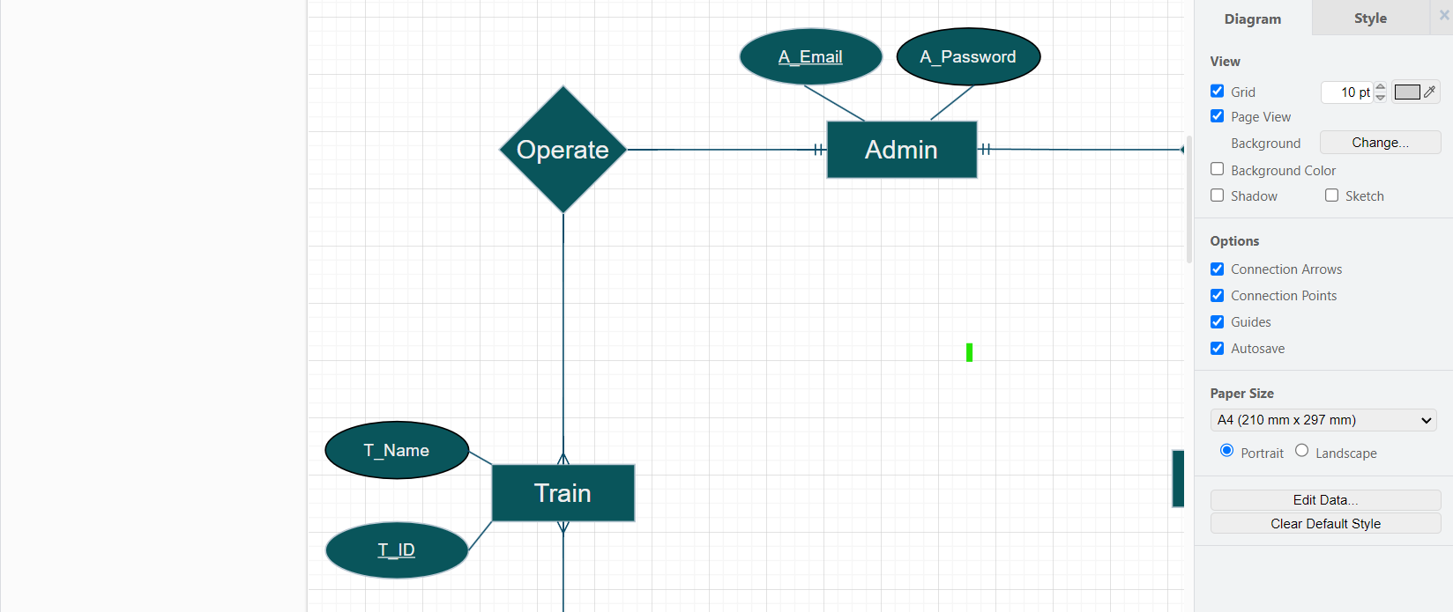**Operate (**Admin **Operate** Train**)**

**UNF : A_Email**, A_Password, **T_ID**, T_Name

**1NF : A_Email**, **T_ID**, A_Password, T_Name

**2NF : 1st : A_Email**, A_Password

**2nd :** **T_ID**, T_Name, **A_Email**

**3NF : 1st : A_Email**, A_Password

**2nd :** **T_ID**, T_Name, **A_Email**

1. **Has (**Train **has** Route**)**

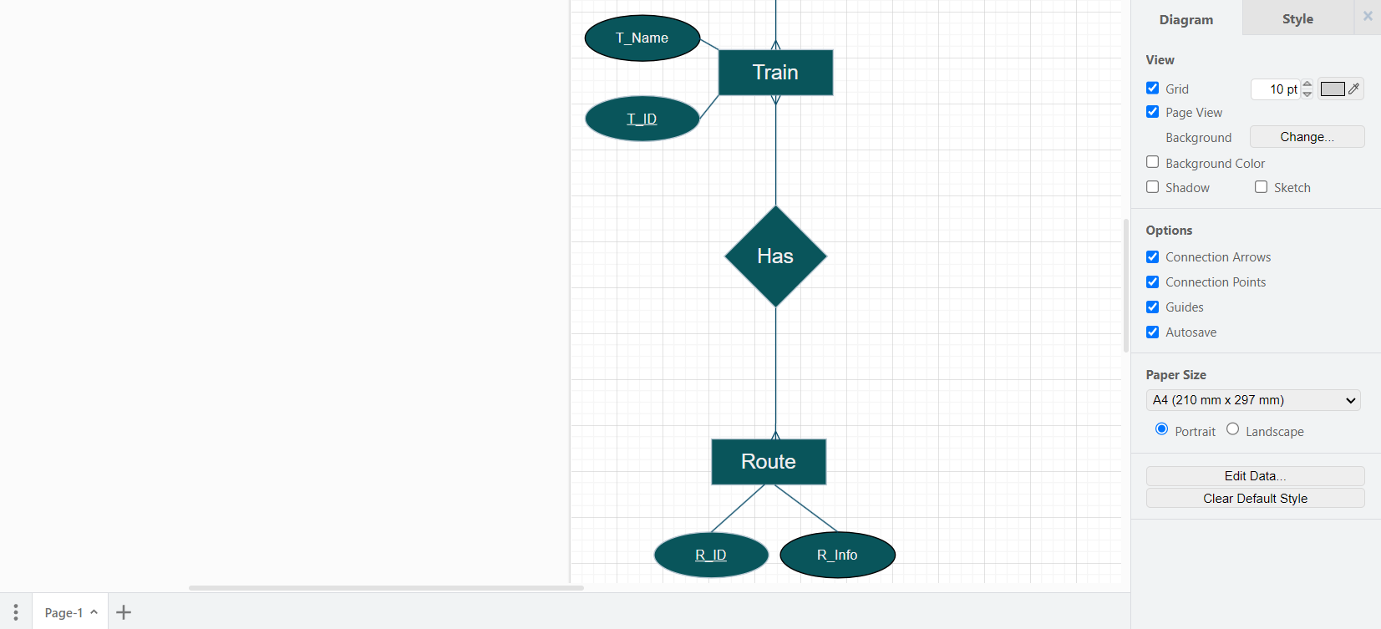

**UNF : T_ID**, T_Name, **R_ID**, R_Info

**1NF : T_ID**, T_Name, **R_ID**, R_Info

**2NF : 1st : T_ID**, T_Name

**2nd :** **R_ID**, R_Info

**3rd : T_ID**, **R_ID**

**3NF : 1st : T_ID**, T_Name

**2nd :** **R_ID**, R_Info

**3rd : T_ID**, **R_ID**

1. **Manage (**Admin **Manage** Ticket**)**

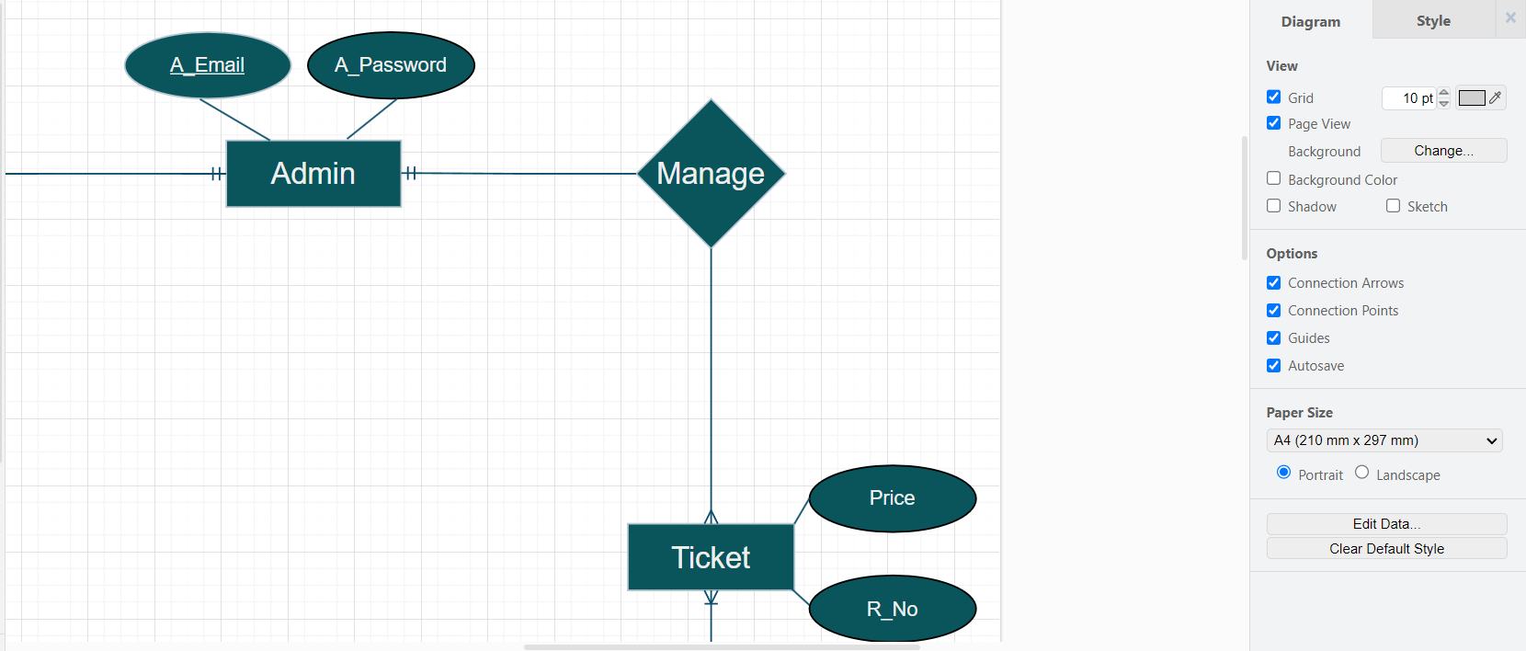

**UNF : A_Email**, A­_Password, R_No, Price

**1NF : A_Email**, A­_Password, R_No, Price

**2NF :**

**1st : A_Email**, A_Password

**2nd :** R_No, Price, **A_Email**

**3NF :**

**1st : A_Email**, A­_Password

**2nd :** R_No, Price, **A_Email**

1. **Purchase (**Passenger **Purchase** Ticket**)**

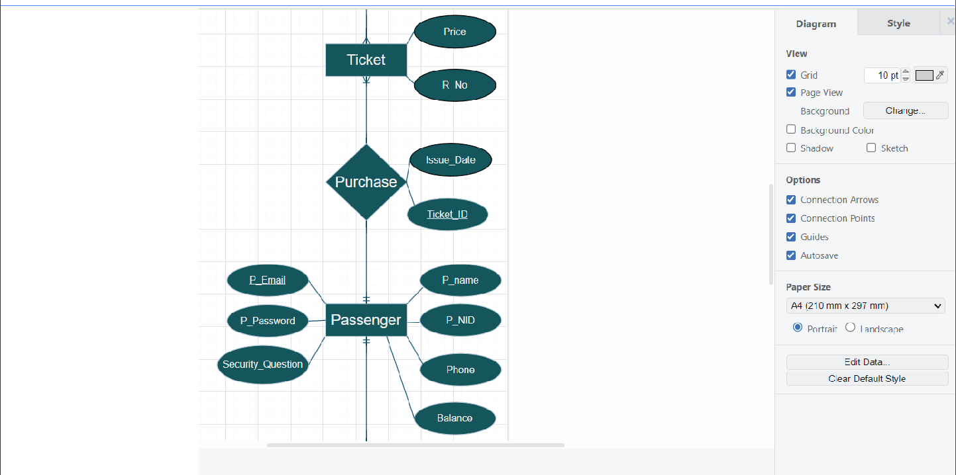

**UNF :** R_No, Price, **Ticket_ID**, Issue_Date, **P_email**, P_Password, P_Name, P_NID, Phone, Balance, Security_Question

**1NF : Ticket_ID**, Issue_Date, R_No, Price, **P_email**, P_Password, P_Name, P_NID, Phone, Balance, Security_Question

**2NF :**

**1st : Ticket_ID**, **P_email**, R_No, Price, Issue_Date

**2nd :** **P_email**, P_Password, P_Name, P_NID, Phone, Balance, Security_Question

**3NF :**

**1st : Ticket_ID**, **P_email**, R_No, Price, Issue_Date

**2nd :** **P_email**, P_Password, P_Name, P_NID, Phone, Balance, Security_Question

1. **Has (**Passenger **Has** Ticket History**)**

**UNF : Ticket­_ID**, T_Name, Departure_satation, Arrival_station, Issue_Time, Price, **P_Email**, P_Password, P_Name, P_NID, Phone, Balance, Security_Question

**1NF : Ticket­_ID**, T_Name, Departure_satation, Arrival_station, Issue_Time, Price, **P_Email**, P_Password, P_Name, P_NID, Phone, Balance, Security_Question

**2NF :**

**1st : Ticket­_ID**, T_Name, Departure_satation, Arrival_station, Issue_Time, Price, **P_Email**

**2nd :** **P_Email**, P_Password, P_Name, P_NID, Phone, Balance, Security_Question

**3NF :**

**1st : Ticket­_ID**, T_Name, Departure_satation, Arrival_station, Issue_Time, Price, **P_Email**

**2nd :** **P_Email**, P_Password, P_Name, P_NID, Phone, Balance, Security_Question

**Finalization**

1st : **A_Email**, A_Password

2nd **:** **T_ID**, T_Name, **A_Email**

3rd : **T_ID**, T_Name

4th : **R_ID**, R_Info

5th : **T_ID,** **R_ID**

6th : **A_Email**, R_No, Price

7th : **Ticket_ID**, **P_email**, R_No, Price, Issue_Date

8th : **P email**, P_Password, P_Name, P_NID, Phone, Balance, Security_Question

9th : **Ticket­_ID**, **P_Email** , T_Name, Departure_satation, Arrival_station, Issue_Time, Price

**Schema Creation**

create user BANGLADESHRAILWAY identified by BANGLADESHRAILWAY;

grant connect, resource, unlimited tablespace to BANGLADESHRAILWAY;

ALTER USER BANGLADESHRAILWAY DEFAULT TABLESPACE USERS;

ALTER USER BANGLADESHRAILWAY TEMPORARY TABLESPACE TEMP;

**Table Creation**

1. create table Admin_Info (A_Email varchar2(32) primary key, A_Password varchar (32));

1. create table Admin_Operate_Train(T_ID number(12) primary key, T_Name varchar2(32),A_Email varchar2(32), foreign key (A_Email) references Admin_Info(A_Email));

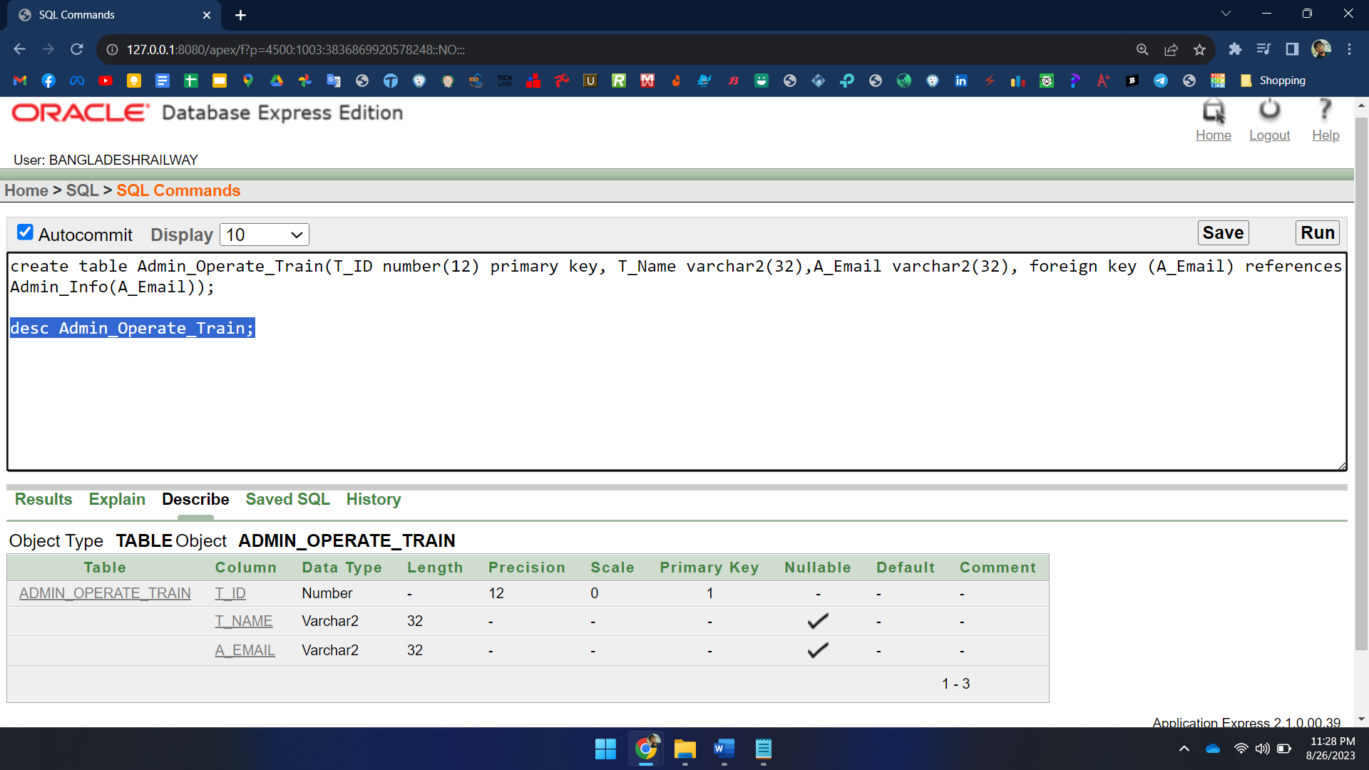

1. A screenshot of a computer

   Description automatically generatedcreate table Train_Info (T_ID number (10) primary key, T_Name varchar2(35) Not Null);
2. A screenshot of a computer

   Description automatically generatedcreate table Route_Info (R_ID number (10) primary key, R_Info varchar2(35) Not Null);
3. create table TR_Info (T_ID number (12), R_ID number (12), primary key (T_ID, R_ID), foreign key (T_ID) references Train_Info(T_ID),foreign key (R_ID) references Route_Info(R_ID));

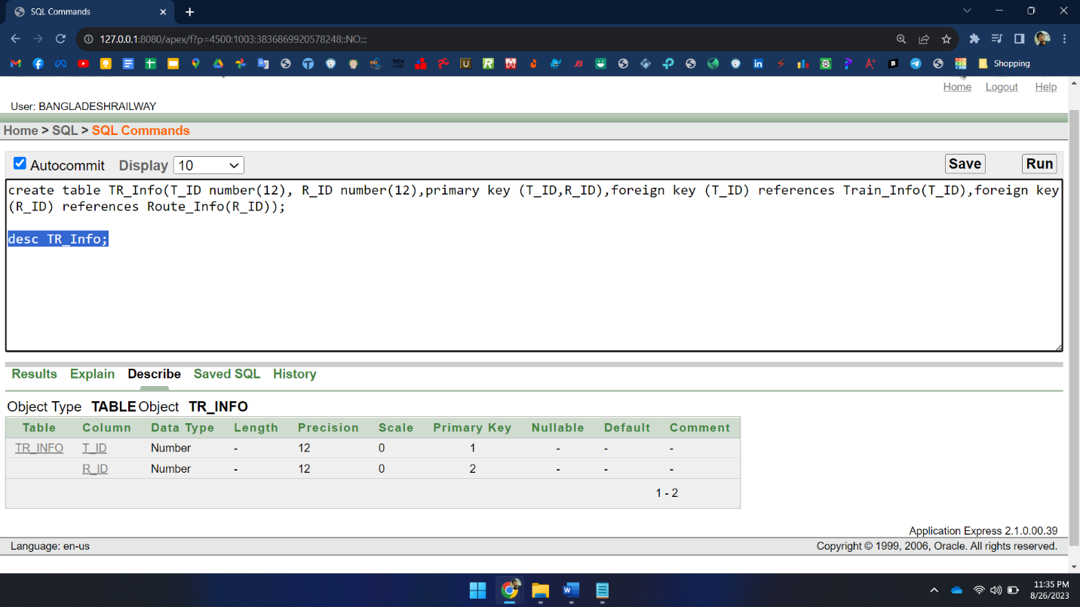

1. A screenshot of a computer

   Description automatically generatedcreate table Admin_Manage_Ticket (R_No number (10), price float, A_Email varchar2(32), foreign key (A_Email) references Admin_Info(A_Email));
2. A screenshot of a computer

   Description automatically generatedcreate table Ticket_Info (R_No number (12) Not Null, Ticket_ID number (12) primary key, Price float, Issue_Date varchar2(32), P_Email varchar2(32), foreign key (P_Email) references Passenger_Details(P_Email));
3. A screenshot of a computer

   Description automatically generatedcreate table Passenger_Details (P_Email varchar2(32) primary key, P_Name varchar2(30) Not Null, P_NID number (15) Not Null, P_Password varchar2(30) Not Null, Security_Question varchar2(50), Balance float, Phone number(12));
4. A screenshot of a computer

   Description automatically generatedcreate table Ticket_History (Ticket_ID number (15) primary key, T_Name varchar2(32), Departure_sattion varchar2(32), Arrival_station varchar2(32), Issue_time varchar2(32), Price float, P_Email varchar (32), foreign key (P_Email) references Passenger_Details(P_Email));

**Data Insertion**

1. 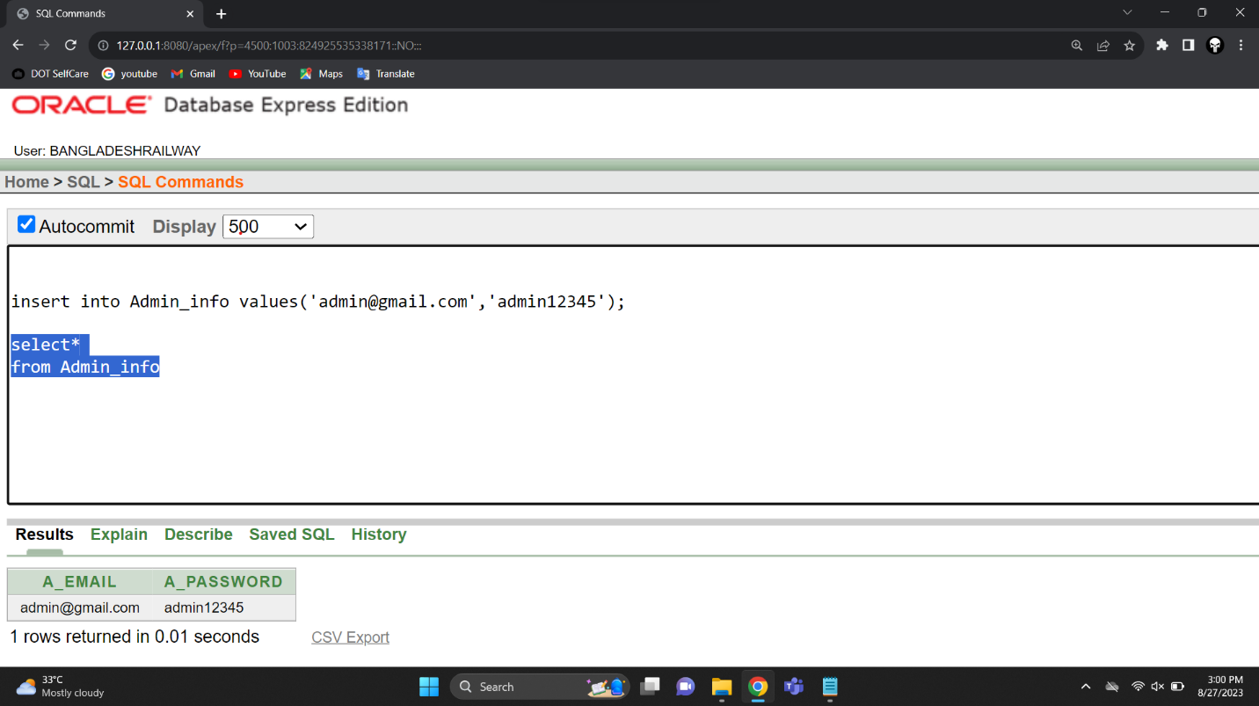**Admin_Info**
2. 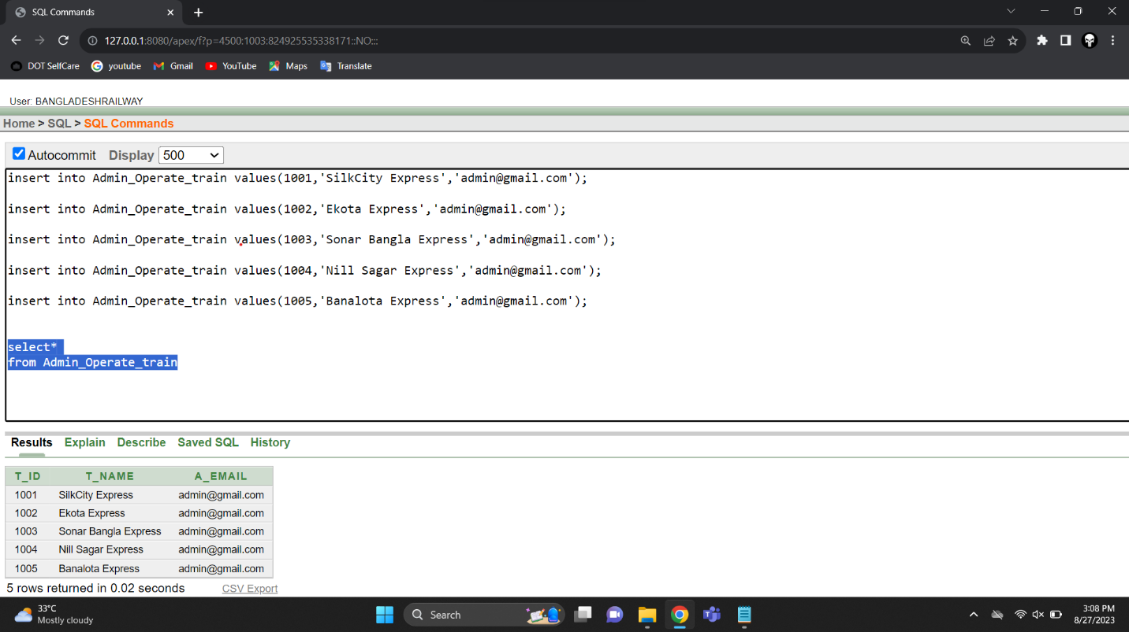**Admin_Operate_Train**
3. 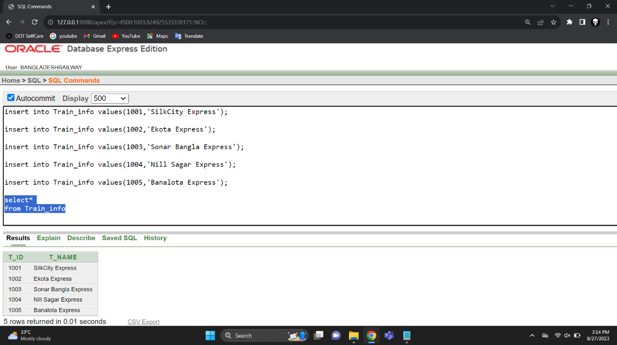**Train_Info**
4. 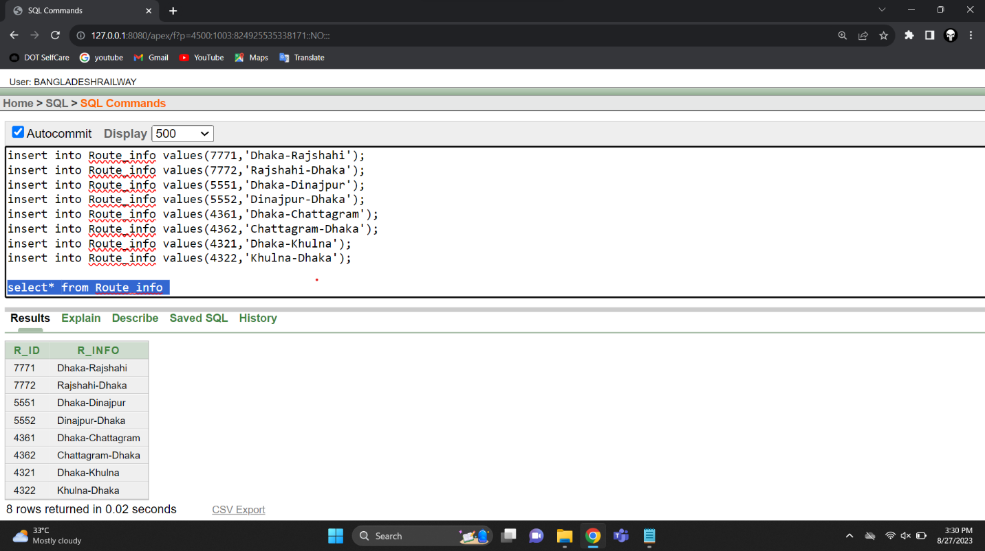**Route_Info**
5. 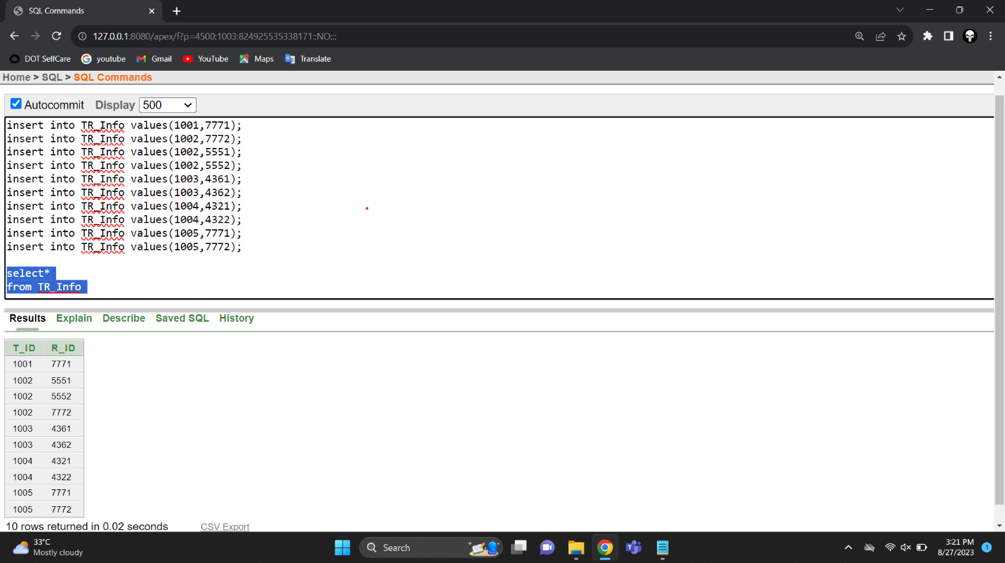**TR_Info**
6. **Admin_Manage_Ticket**

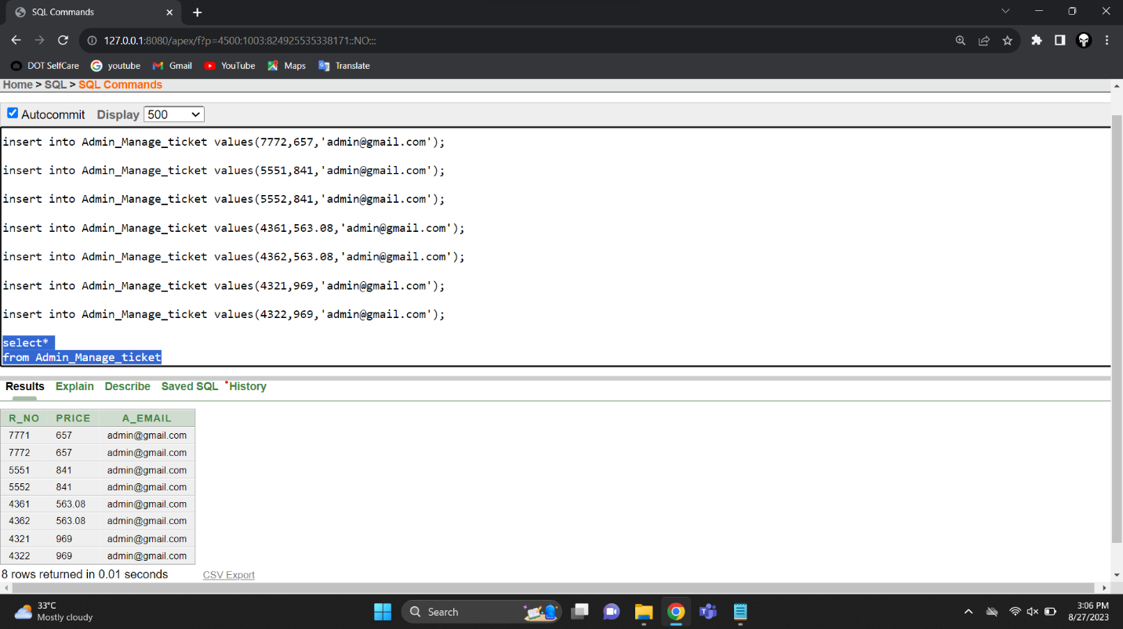

1. **Passenger_Details**

**Subquery**

1. **Show all the train Information that has a route of Dhaka to Rajshahi.**

select * from Train_Info where T_ID in(select T_ID from TR_Info where R_ID = (select R_ID from Route_Info where R_Info ='Dhaka-Rajshahi'));

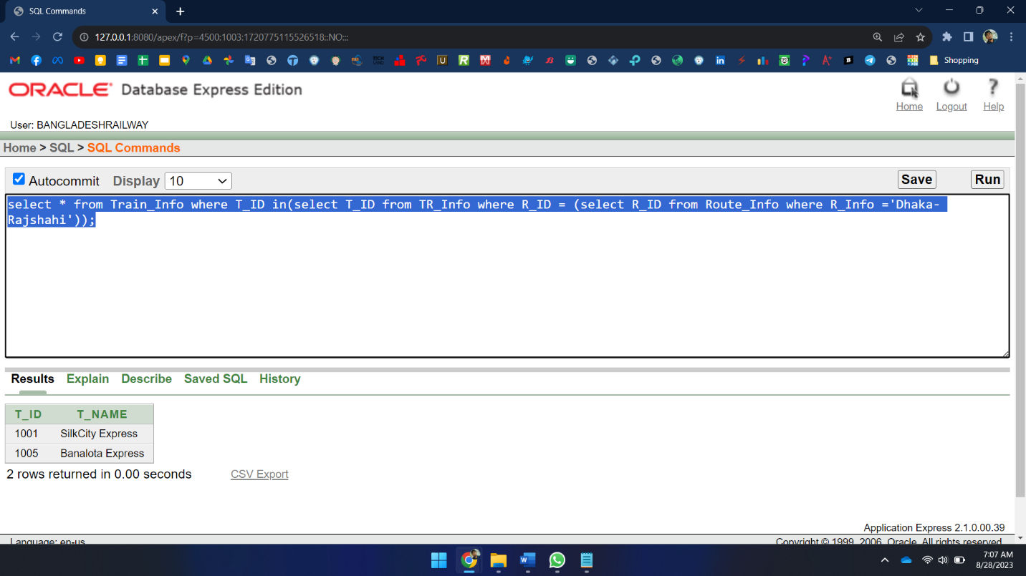

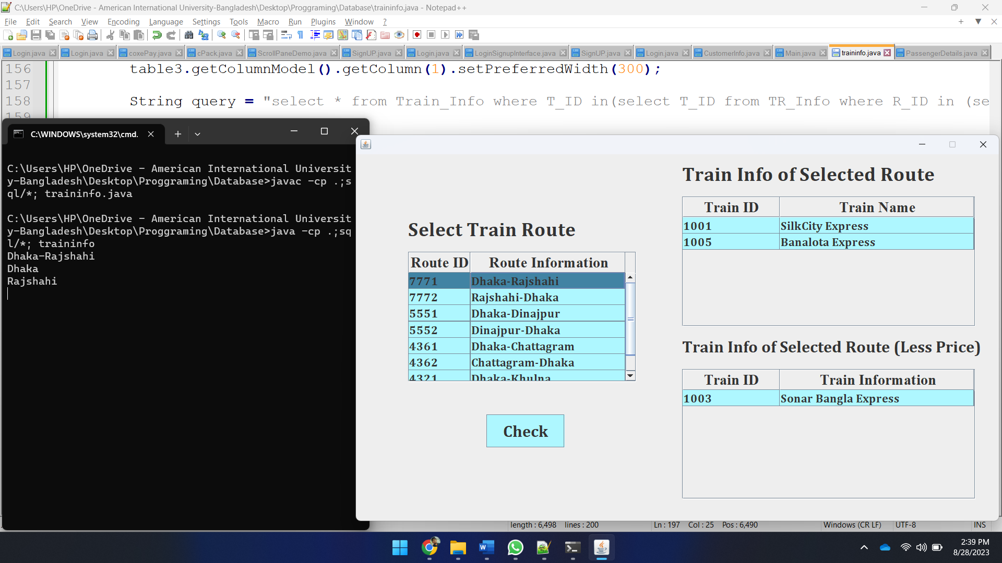

1. **Show all the Train information those who have less fare price than Dhaka to Dinajpur route.**

select * from Train_Info where T_ID in(select T_ID from TR_Info where R_ID in (select R_NO from Admin_Manage_Ticket where Price<(select price from Admin_Manage_Ticket where R_NO=(select R_ID from Route_Info where R_Info = 'Dhaka-Dinajpur'))));

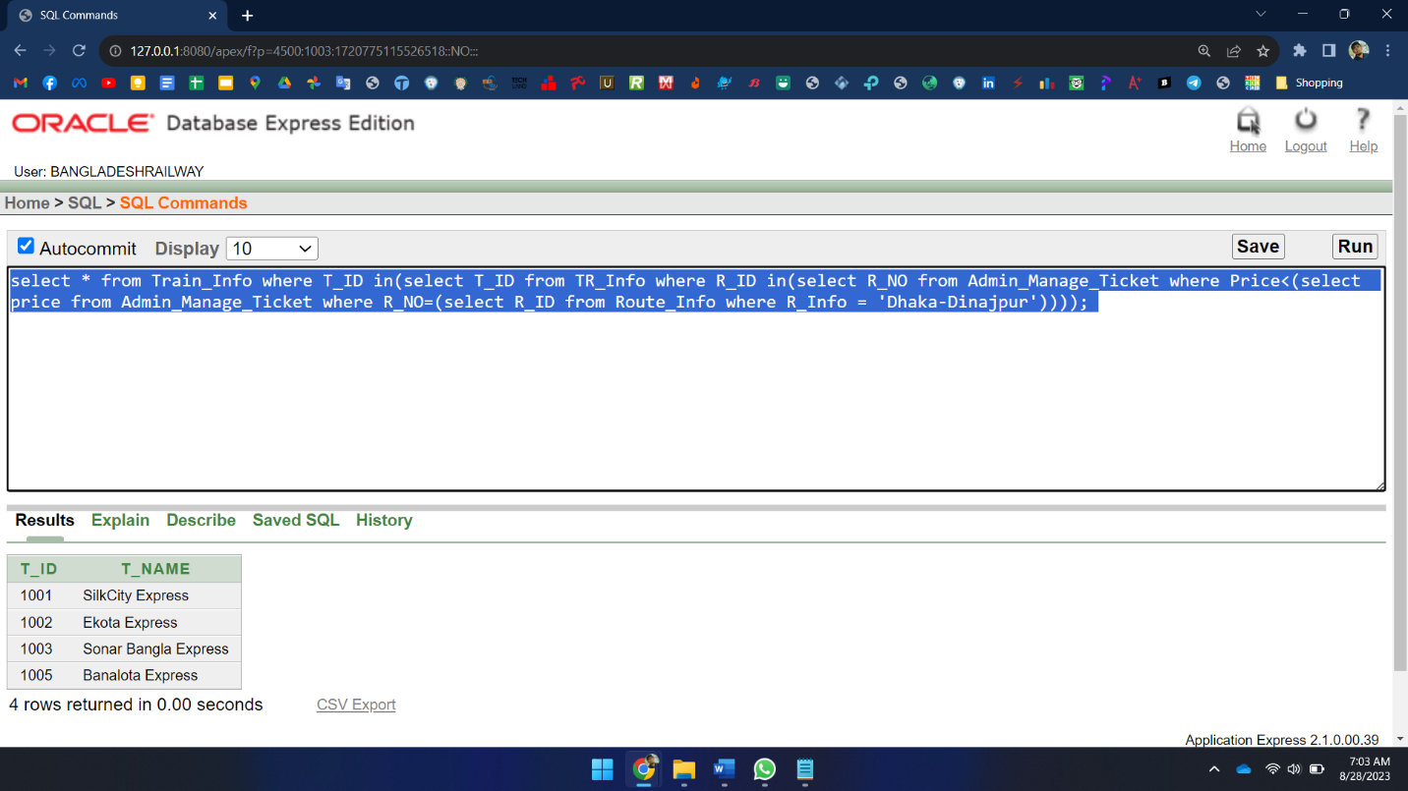

1. **Show all the user names & NID who have more balance than Md. Sazzad.**

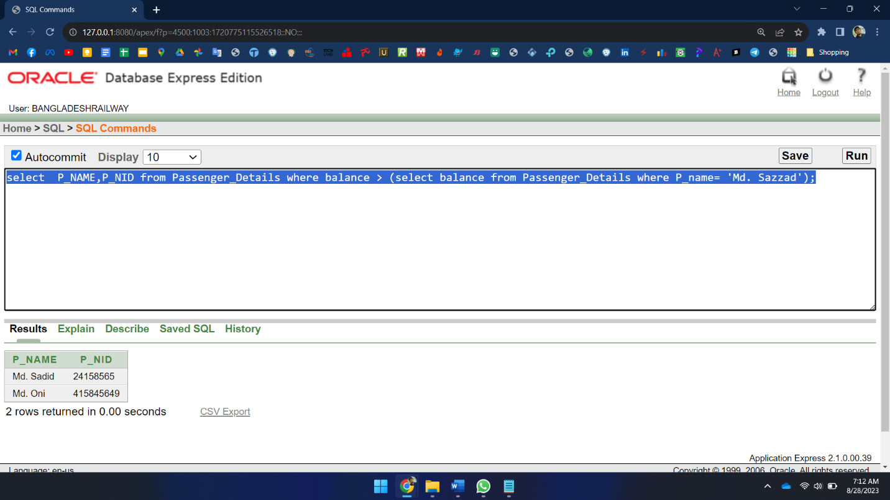 select P_NAME,P_NID from Passenger_Details where balance > (select balance from Passenger_Details where P_name= 'Md. Sazzad');

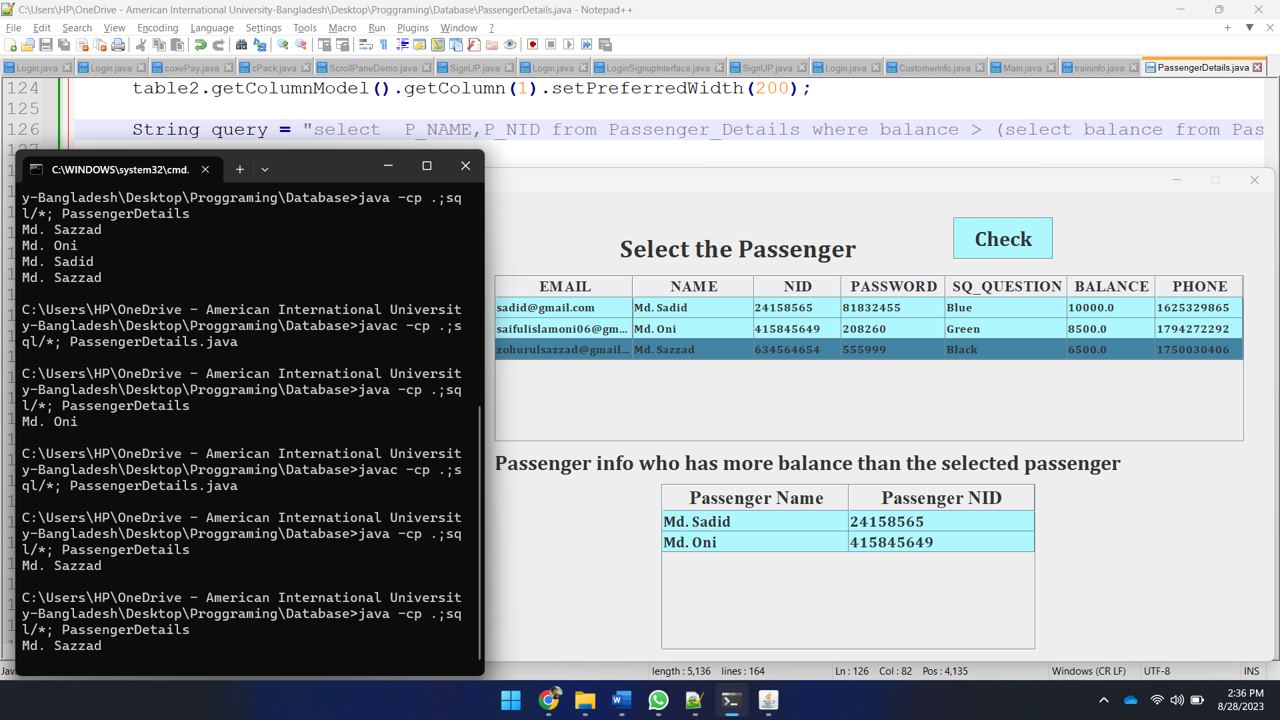

**Joining Query**

1. **Equijoin**
   1. **Show the Route information with price.**

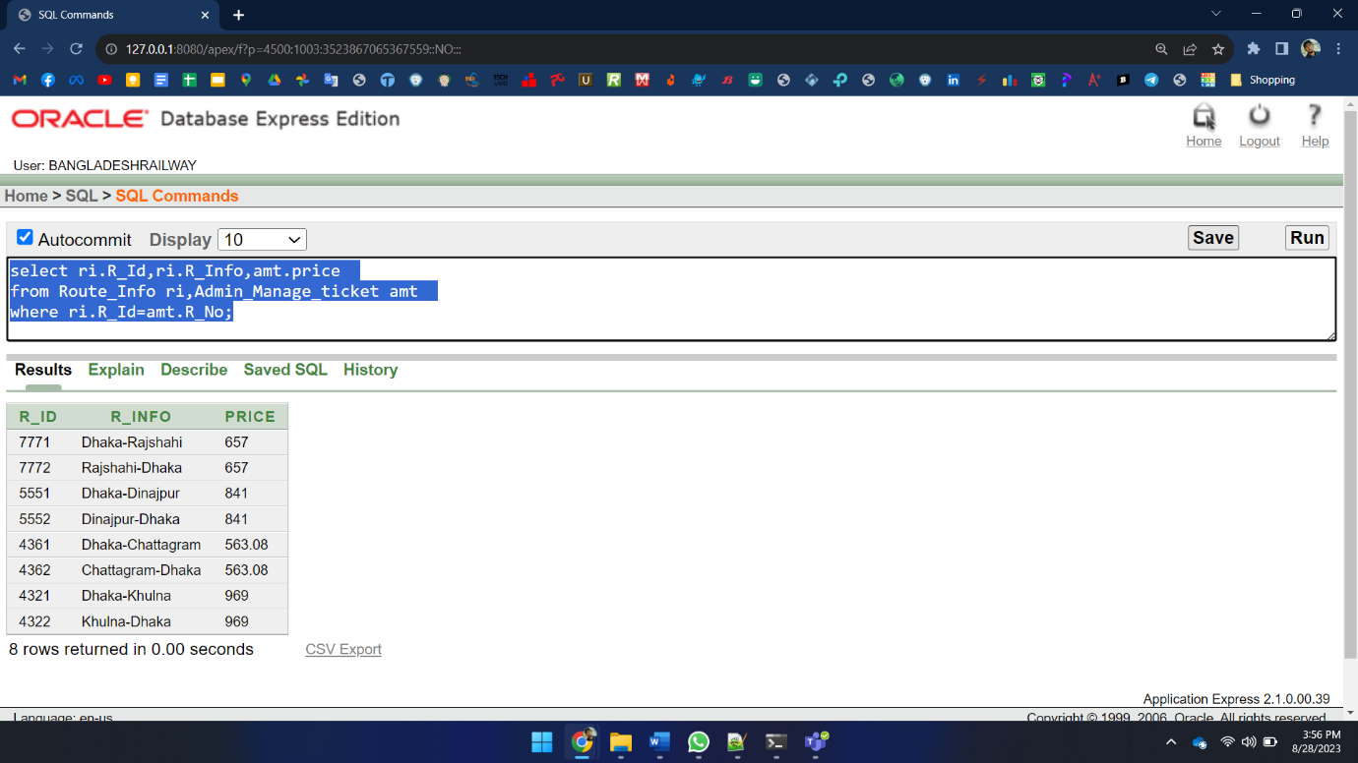select ri.R_Id,ri.R_Info,amt.price from Route_Info ri,Admin_Manage_ticket amt where ri.R_Id=amt.R_No;

1. **Outer join** 
   1. **Show all the train information with route ID for all the existing trains.**

select t.*, tr.r_id from train_info t, TR_Info tr where t.t_id=tr.t_id(+);

* 1. **Show all the route information with Train ID for all the existing routes.**

select r.*, tr.t_id from route_info r, tr_info tr where tr.r_id(+)=r.r_id order by r.r_id;

1. **Self-join** 
   1. **Show the names who has more balance than whom. And rename the column as “Person1 has more balance than Person2”.**

select a.P_NAME ||' '||'Has more balance than'||' '|| b.P_NAME

from PASSENGER_DETAILS a, PASSENGER_DETAILS b

where a.BALANCE>b.BALANCE;

